**写作指导**

**写作任务(Section B 3c)**

下周英语口语课上，老师要求大家就自己的好习惯和坏习惯进行总结和反思。请你用英语写一篇短文介绍自己的习惯，为课堂发言做准备。

**●【审清题目】**

**内容：**介绍自己的好习惯和坏习惯。

**文体：**说明文。

**时态：**介绍日常习惯时，用一般现在时。

**人称：**第一人称。

**●【头脑风暴】**

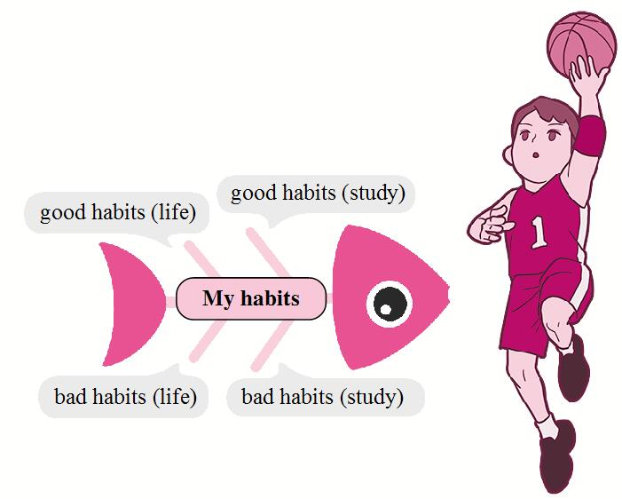

**●【提供素材】**

**◆语块** 补全下列语块对应的英文表达。

|  |  |  |
| --- | --- | --- |
| **习惯**  **（生活、学习）** | **具体内容** | **频率** |
| **好习惯** | ▲exercise / play sports, go running / do some running, (1)______________  (帮助做家务), drink water / juice instead of (而不是) cola or drinks, eat fruit and vegetables instead of junk food, (2)______________(去看牙医), brush teeth, (3)______________(早睡早起), wash your hands before and after a meal, throw waste in the bin (把废物扔进垃圾桶), keep the house clean, keep your desk tidy, get enough sleep and rest  ▲go to the library to read, plan (计划) your time wisely (明智地), take notes (做笔记), (4)______________(按时完成作业), listen to the teacher carefully (认真地), review (复习) your notes after class, bring your homework to school, ask the teacher questions | (almost) every  day, once / twice  a week / month, three / four / ... times a week,  (5)______________(几乎从不), never, always, usually,  often, sometimes |
| **坏习惯** | ▲**本身对健康有害**  (6)______________(熬夜), eat junk food or fast food, play games on your mobile phone in bed, read in moving cars, don't finish homework on time, don't listen in class  **▲由于频率高而对自己不利**  watch TV, eat candy, (7)______________(使用互联网), play computer games, eat hamburgers | all day, always,  often, every day,  (8)______________(三个多小时) |

**Key:**(1) help with housework  (2) go to the dentist

(3) get up early and go to bed early  (4) finish homework on time

(5) hardly ever  (6) stay up late   (7) use the Internet

(8) more than / over three hours

**◆句型**

I have some good / bad habits such as ...

It's good for my health.

I hardly ever / often / never ...

I … three times / ... a week.

It's not easy to give up (放弃) bad habits.

As the saying goes, never leave today's work until tomorrow.

The early bird catches the worm (早起的鸟儿有虫吃).

It's never too late to learn.

An apple a day keeps the doctor away.

**●【谋篇布局】**

将括号内的汉语翻译成英语，补全短文。

**引出话题**

Good morning, everyone. I want to tell you about some of my habits here.

**介绍“我”的好习惯及理由**

I have some good habits. I like playing sports, so I (1)____________________(几乎每天打篮球) after school. I never stay up late because (2)____________________(这对我的健康不利). What's more, I take notes carefully in class. I think it can (3)____________________(帮我记住一切) the teacher says.

**介绍“我”的坏习惯及改正决心**

However, I have some bad habits, too. (4)____________________(我几乎从不吃水果). I know an apple a day makes the doctor away, so I am going to eat more fruit from now on. Also, I (5)____________________(经常看电视) after dinner and sometimes I almost forget to do my homework.

**结尾**

Old habits die hard, but it's never too late to give them up. As for my good habits, I will try to keep them.

That's all. Thank you.

**Key:** (1) play basketball almost every day   (2) it's not good for my health

(3) help me remember everything  (4) I hardly ever eat fruit  (5) often watch TV